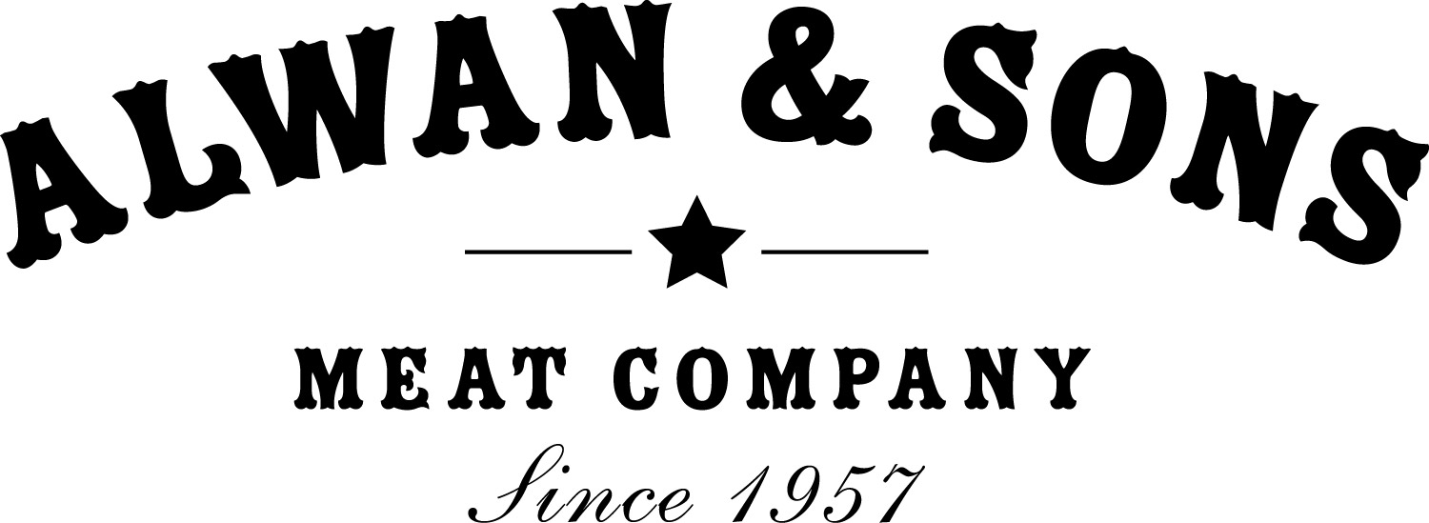

703 E War Memorial Dr., Peoria Heights, IL 61616
P: (309) 688-8711 F: (309) 688-8718
Application for Employment
Pre-employment Questionnaire Equal Opportunity Employer

PERSONAL INFORMATION
Name (Last, First) |  | Date
Address |  | City, State
Phone No. | Secondary Phone No. | Referred By

EMPLOYMENT DESIRED
Position | Date You Can Start | Salary Desired
Are You Employed Now?  YES NO | If so, may we inquire of your present employer? YES NO | Are you legally authorized to work in the US? YES NO
Have you ever applied to Alwan & Sons Meat Co. before?
If so, when?

EDUCATION HISTORY
 | Name & Location of School | Years Attended | Did You Graduate | Subjects Studied
High School
College
Trade, Business, or Correspondence School

GENERAL INFORMATION
Subject of Special Study/Research Work
Special Training
Special Skills
U.S. Military or Naval Service | Rank

FORMER EMPLOYERS (List Below Four Last Employers, Starting With Last One First)
Date (Month, Year) | Name & Address of Employer | Salary | Position | Reason for Leaving
From
To
From
To
From
To
From
To

REFERENCES: Give Below The Names Of Three Persons Not Related To You, Whom You Have Known At Least One Year.
Name | Address/Phone No. | Business | Years Known

AUTHORIZATION
“I certify that the facts contained in this application are true and complete to the best of my knowledge and understand that, if employed, falsified statements on this application shall be grounds for dismissal.
I authorize investigation of all statements contained herein and the references and employers listed above to give you any and all information concerning my previous employment and any pertinent information they may have, personal or otherwise, and release the company from all liability for any damage that may result from utilization of such information.
I also understand and agree that no representative of the company has any authority to enter into any agreement for employment for any specified period of time, or to make any agreement contrary to the foregoing, unless it is in writing and signed by an authorized company representative.
This waiver does not permit the release or use of disability-related or medical information in a manner prohibited by the Americans with Disabilities Act (ADA) and other relevant federal and state laws.”

DATE_________________________________ SIGNATURE_______________________________________________

INTERVIEWED BY__________________________________________ DATE_________________________________
Please Contact our HR Manager: Michelle Alwan
E: michelle@alwanandsons.com

----------------------------------------- OFFICE USE ONLY: DO NOT WRITE BELOW THIS LINE --------------------------------------

REMARKS

Neatness |  |  | Character
Personality |  |  | Ability
Hired | Department | Position | Will Report | Salary/Wages

